MENTAL RETARDATION BULLETIN
COMMONWEALTH OF PENNSYLVANIA DEPARTMENT OF PUBLIC WELFARE

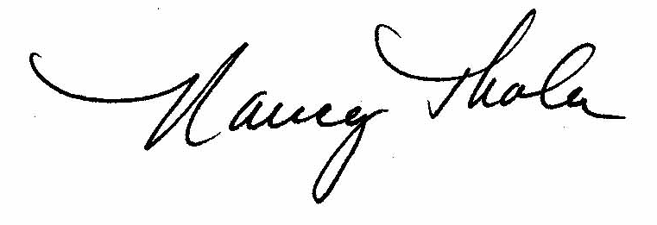

INCIDENT MANAGEMENT INTERPRETIVE
GUIDELINE – Hospital Discharge Instructions


DATE OF ISSUE
November 27, 2002
EFFECTIVE DATE
Immediately
NUMBER
00-02-15
SUBJECT:
BY:

Nancy R. Thaler
Deputy Secretary for Mental Retardation

SCOPE:

County MH/MR Program Administrators
Base Service Unit Directors
Community Home Directors
Family Living Directors
Adult Training Facility Directors
Vocational Facility Directors
Early Intervention Program Directors
Non-State Operated Intermediate Care Facilities
for the Mentally Retarded (ICF/MR) Directors
State Operated Intermediate Care Facilities for
the Mentally Retarded (ICF/MR) Directors

PURPOSE:

This bulletin is intended to give interpretive guidance to providers and counties regarding the reporting of incidents involving a hospitalization. This interpretive guideline is for the Final Report section (page 13) of the Office of Mental Retardation Bulletin, 00-01-05 Incident Management.

BACKGROUND:

On August 27, 2001, the Office of Mental Retardation (OMR) issued policy bulletin
COMMENTS AND QUESTIONS REGARDING THIS BULLETIN SHOULD BE DIRECTED TO:
Appropriate Mental Retardation Regional Program Managers
00-01-05, Incident Management. A phased implementation began on March 25, 2002. Since the implementation of the policy, OMR has been closely monitoring issues related to implementation and anticipates that the incident management policy will be modified based upon feedback from focus groups and data gathered in the Home and Community Services Information System (HCSIS). Office of Mental Retardation Bulletin, Incident Management, 00-01-05 contains a requirement that the Final Report is to include an indication that the Hospital Discharge Summary was provided, a summary of its contents and a description of any plans for subsequent medical follow-up. OMR has determined that following a hospitalization the “Hospital Discharge Instructions,” which are issued to all hospital patients upon discharge, is the more appropriate and relevant document to obtain.

GUIDELINE:

Hospital Discharge Instructions

Provider and county staff should apply the following guideline when reporting incidents involving inpatient hospitalization.

County and OMR staff are to follow this guideline when completing management reviews of incidents involving inpatient hospitalization.

With the effective date of this bulletin, the “Hospital Discharge Instructions” are to be obtained instead of the “Hospital Discharge Summary.” Additionally, the HCSIS IM application Final Report will be changed by removing the phrase “Hospital Discharge Summary” and it will now state “Hospital Discharge Instructions.”

Note: For the reporting of Deaths, the requirement remains to obtain the Hospital Discharge Summary.

